**Institute of Technology Tralee**

**BSc. in Computing with Specialism (Group A) - Year 1**

**Continuous Assessment #1**

**Date: 6/11/12**

**Time: 10 – 12 p.m.**

**Introduction to Programming**

**Instructions:** Attempt the following question. You should use the Just BASIC IDE for coding. When you are finished you must print out your code for correction.

**________________________________________________________**

**Q1.**

Under the taxation system employed by the Irish Government, the amount of tax an employee owes (PAYE) for a given months work can be calculated using the following formula:

PAYE = [20% of Cut-off Point] + [42% of (Gross Income – Cut-Off Point – Pension Payments)] – [Tax Credits]

The formula above only applies if the employee’s gross income **exceeds** the cut-off point value. If however this is not the case, then the following formula is used instead:

PAYE = [20% of (Gross Income – Pension Payments)] – [Tax Credits]

Write a Just BASIC program that asks the user to enter their gross income for the month, their cut-off point (this is just a certain amount of Euro), their pension payments and their tax credits (again, just a certain amount of Euro) and uses the formulae above to determine the correct PAYE owed by that employee for their months work.

Your program should also contain a little fool-proofing code. The fool-proofing code will ensure that the user enters valid gross income and valid cut-off point values (any negative value is considered invalid here). If either of these amounts are invalid then the program should immediately terminate with a suitable warning message given to the user and perform no further processing.

Otherwise, your program should display the PAYE owed by the employee to **2 decimal places**.

Using the test values as indicated in the screen shots below, the program should give you **exactly** the following output when it runs, including any banners, blank lines etc.

Also note that there will be a few marks awarded for the use of **meaningful variable names**, having a **meaningful comment at the top of the program** and for **proper indentation** in the coding of the program.

**Sample Screen Shots**

**All quantities entered are valid here and gross income exceeds cut-off point**

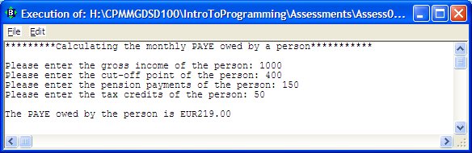

**Invalid gross income here**

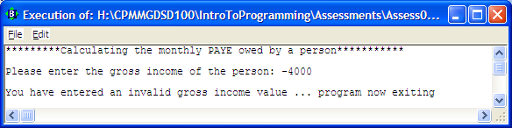

**Invalid cut-off point here**

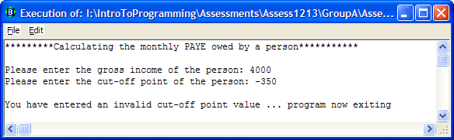

**All quantities entered are valid here and gross income is less than cut-off point**

